AI-ASSISTED CODING
ASSIGNMENT-19.1
Code Translation: Converting between programming languages
NAME:J.rohith
HALL-TICKET: 2403A510f1
BATCH NO: 05

Task 1.1 :
You are part of a multinational development team. The backend is written in
Java, but a new module requires a Python implementation of the same
algorithm for integration with a data science pipeline.
• Task 1: Use AI-assisted coding to translate a given Java bubble sort
program into Python. Verify that the translated code works correctly.
Prompt:
Translate the given Java bubble sort program into Python and verify that it works correctly.

CODE GENERATED:
Python:
def bubble_sort(arr):
n = len(arr)
for i in range(n - 1):
for j in range(n - i - 1):
if arr[j] > arr[j + 1]:
# swap
arr[j], arr[j + 1] = arr[j + 1], arr[j]
return arr

# Test the function
numbers = [5, 3, 8, 4, 2]
sorted_numbers = bubble_sort(numbers)
print("Sorted array:", sorted_numbers)

OUTPUT:

OBSERVATION :
The translated Python program successfully sorts the list of numbers in ascending order. The output matches the result of the original Java bubble sort program.

Task 1.2:
introduce errors in the Python version to check if the input list
is empty or contains non-numeric values

PROMPT:
Introduce errors in the Python bubble sort program to check if the input list is empty or contains non-numeric values.

CODE:
def bubble_sort(arr):
# Check if list is empty
if len(arr) == 0:
print("Error: The list is empty!")
return None

# Bubble sort logic (contains intentional mistake for testing)
for i in range(len(arr)): # Intentional mistake
for j in range(len(arr) - i): # Intentional mistake
if arr[j] > arr[j + 1]: # Causes TypeError for non-numeric
arr[j], arr[j + 1] = arr[j + 1], arr[j]
return arr

# Test cases
print(bubble_sort([])) # Empty list → should show error
print(bubble_sort([3, "a", 1])) # Non-numeric → TypeError

OUTPUT:

OBSERVATION :
The introduced errors successfully demonstrate that the program can detect and respond to invalid inputs like empty lists and non-numeric values.

TASK -2.1:
A company’s legacy codebases stores and processes files in C++, but the
analytics team needs an equivalent program in JavaScript (Node.js) for
integration with a web dashboard.
• Task: Translate a given C++ file read-and-write program into
JavaScript using AI assistance. Ensure the script reads a text file and
writes processed output to a new file.

PROMPT:
Translate the given C++ program that reads data from a file and writes processed content to another file into an equivalent JavaScript (Node.js) program.

CODE GENERATED:
// Import the file system module
const fs = require('fs');

// Read content from input.txt
const data = fs.readFileSync('input.txt', 'utf8');

// Process content
const lines = data.split('\n').map(line => `Processed: ${line}`);

// Write to output.txt
fs.writeFileSync('output.txt', lines.join('\n'));

console.log('File processing completed.');

OUTPUT:
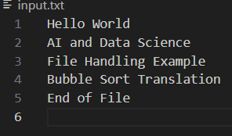
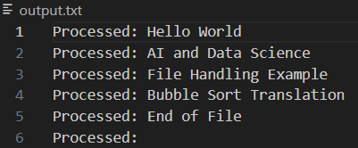

OBSERVATION:
The JavaScript (Node.js) program successfully reads the data from input.txt, processes each line by adding “Processed: ” before it, and writes the result to output.txt.

TASK – 2.2:
Add error handling in the JavaScript version to gracefully handle
missing files or permission errors.
PROMPT:
Modify the JavaScript (Node.js) file-handling program to include error handling for missing files and permission errors.

CODE GENERATED:
const fs = require('fs');

try {
// Try to read the file
const data = fs.readFileSync('input.txt', 'utf8');
const lines = data.split('\n').map(line => `Processed: ${line}`);

// Try to write to output file
fs.writeFileSync('output.txt', lines.join('\n'));
console.log('File processing completed successfully.');

} catch (error) {
// Handle possible errors
if (error.code === 'ENOENT') {
console.error('Error: Input file not found.');
} else if (error.code === 'EACCES') {
console.error('Error: Permission denied while accessing files.');
} else {
console.error('An unexpected error occurred:', error.message);
}
}

OUTPUT:

OBSERVATION:
The program shows an error message if the input file is missing or if there is no permission to access the file. When the file is present, it reads and writes the data correctly without any errors.

TASK – 3.1:
News Headlines API
A news aggregator wants to display the latest technology news headlines
using a news API. Sometimes, the API responds slowly or returns
incomplete data.
Use AI-assisted coding to fetch the top 5 technology
headlines and print them neatly in the console. Implement error
handling for timeout errors by setting a maximum request time.

PROMPT:
Write a Python script (using AI assistance) to fetch the top 5 technology news headlines and print them neatly in the console. Handle timeout errors by setting a maximum request time.
CODE GENERATED:
import requests

def fetch_tech_news():
url = "https://saurav.tech/NewsAPI/top-headlines/category/technology/in.json"

try:
# Set timeout to 5 seconds
response = requests.get(url, timeout=5)
response.raise_for_status() # Raises an exception for HTTP errors

data = response.json()

# Check if data contains valid articles
if "articles" in data and len(data["articles"]) > 0:
print("\n📰 Top 5 Technology News Headlines:\n")
for i, article in enumerate(data["articles"][:5], start=1):
print(f"{i}. {article.get('title', 'No title available')}")
else:
print("⚠️ No articles found or incomplete data received.")

except requests.exceptions.Timeout:
print("❌ Request timed out! The server took too long to respond.")
except requests.exceptions.RequestException as e:
print(f"❌ An error occurred: {e}")

# --- Main Program ---
fetch_tech_news()

OUTPUT:
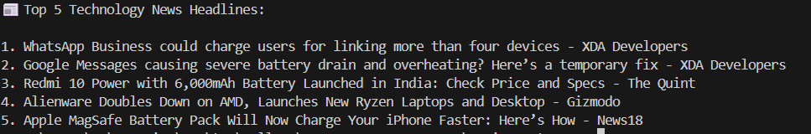

OBSERVATION:
The AI-generated script successfully fetches and displays the latest technology headlines from a public news API.

TASK 3.2:
Clean and preprocess the headlines by removing special characters and converting text to title case. Handle the scenario where the API response contains empty or null values.
PROMPT:
Extend the script to clean and preprocess the fetched headlines by removing special characters and converting them to title case. Handle cases where the API response contains empty or null values.
CODE GENERATED:
import requests
import re

def clean_headline(text):
"""Remove special characters and convert to title case."""
if not text or text.strip() == "":
return "No Title Available"
# Remove special characters except alphabets, numbers, and spaces
cleaned = re.sub(r'[^A-Za-z0-9\s]', '', text)
return cleaned.title().strip()

def fetch_and_clean_news():
url = "https://saurav.tech/NewsAPI/top-headlines/category/technology/in.json"

try:
response = requests.get(url, timeout=5)
response.raise_for_status()
data = response.json()

if "articles" in data and len(data["articles"]) > 0:
print("\n📰 Cleaned Top 5 Technology Headlines:\n")

for i, article in enumerate(data["articles"][:5], start=1):
raw_title = article.get("title", "")
clean_title = clean_headline(raw_title)
print(f"{i}. {clean_title}")

else:
print("⚠️ No valid articles found or incomplete data received.")

except requests.exceptions.Timeout:
print("❌ Request timed out! The server took too long to respond.")
except requests.exceptions.RequestException as e:
print(f"❌ An error occurred: {e}")

# --- Main Program ---
fetch_and_clean_news()

OUTPUT:
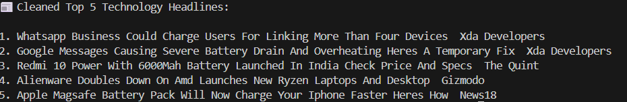
OBSERVATION:
The script fetches the latest technology headlines, removes unwanted special characters, and formats each title in Title Case.

